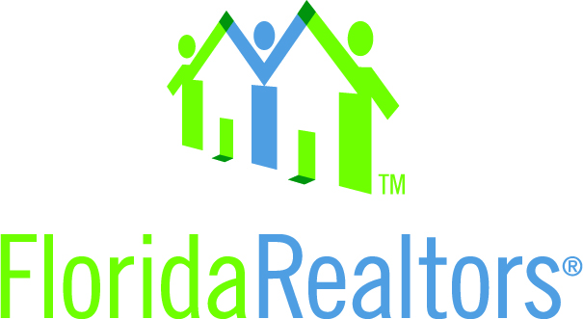

State Leadership Idea Exchange Council – REALTORS® Believe

In working with our community and association partners, Florida Realtors® is honored to have been awarded a NAR Housing Opportunity Program Grant in the amount of $20,000 to raise awareness that “Housing Matters” and engage our membership to make an impact on rising homelessness rates in communities across Florida. Further, as is stated in our Code of Ethics, we believe this is an issue where comment is necessary.

Throughout the summer of 2014, Florida Realtors® will be traveling the state on a “REALTORS® Believe” bus tour bringing awareness on family homelessness to communities across our entire state by visiting district wide conferences spanning all the way from Florida’s panhandle down to the Keys. The title and tagline of the tour “REALTORS® Believe: We believe in our communities, that housing matters and we can make a difference” will draw attention to and recognize the most essential needs and interests of our citizens in the state of Florida, adequate housing and the preservation of a healthy environment.

Our message will be that not only does homeownership matter, but that housing matters. Further, the tour promotes the REALTOR® brand and our state association’s values that include quality of life, REALTOR® visibility, community involvement…we are engaged in the enhancement of our neighborhoods and the sanctity of home… we are dedicated to a safe, comfortable place for families to thrive.

Florida Realtors® intends to engage our collective power to convene business, government and civic leaders in acknowledging that “Housing Matters.” This includes engaging our membership arm, advocacy arm and a third party consultant to achieve defined, measureable goals.

As the 2014 Florida legislative session comes to close, this is the first time in many years where the Florida Legislature had a positive budget surplus. This laid the groundwork for a major success on affordable housing funding. As of this writing, the state budget is coming together and it appears Florida Realtors will secure the largest appropriation in over seven years for housing programs with funding of approximately $170 million. This is a huge victory for Florida Realtors® as we have consistently advocated for this funding. This session, Florida Realtors® testified in support, attended stakeholder meetings in the Capitol, and advocated to legislative leaders behind the scenes that this was an important initiative for Florida Realtors®. It appears we will end up with $4 million of the housing funds dedicated to homelessness initiatives for children.

The REALTORS® Believe bus tour will allow an opportunity for Florida Realtors® to enact a long term initiative to raise awareness in communities across the state on homelessness rates and begin a dialogue working with community partners to provide direction and leadership on public policies necessary to work towards a goal that every family has a roof to sleep under each night.

A new approach to funding this activity was taken in the level of funding request to “bundle” the grant by district conference events. Florida Realtors® is comprised of 13 districts, similar to NAR’s regions. The request was put in one application, with an allotted amount per district to allow for maximum impact and messaging across the entire state.

