Colorado Association of REALTORS®

Studio R Opens New Doors for CAR Communications

Communicating relevant information effectively with 20,000 members’ is a daunting task, especially when they have unique needs and interests. When you add communicating effectively with other industry stakeholders including consumers, it makes the challenge of being the voice in the real estate industry even more challenging. However we feel with the creation of Studio R (our in-house studio; R stand for REALTOR®) we have successfully created an effective solution for these challenges.

Since the creation of Studio R in 2013 we have produced numerous live webcasts on a variety of real estate related topics that we ultimately archive for members to watch on our website. We also create videos for consumers so they understand why they should use a REALTOR® and for members to help them understand the value proposition of CAR and the importance of the REALTOR® brand.

Studio R is complete with a green room, state of the art sound equipment, confidence monitors, and digital and non-digital props to ensure we provide the highest quality of production possible so our audiences can hear our messages loud and clear.

Studio R is an out of the box investment that gives the Colorado Association of REALTORS® the flexibility to meet the core and diverse information needs of our membership and a platform to strengthen our role as the voice to our industry.

Control Room

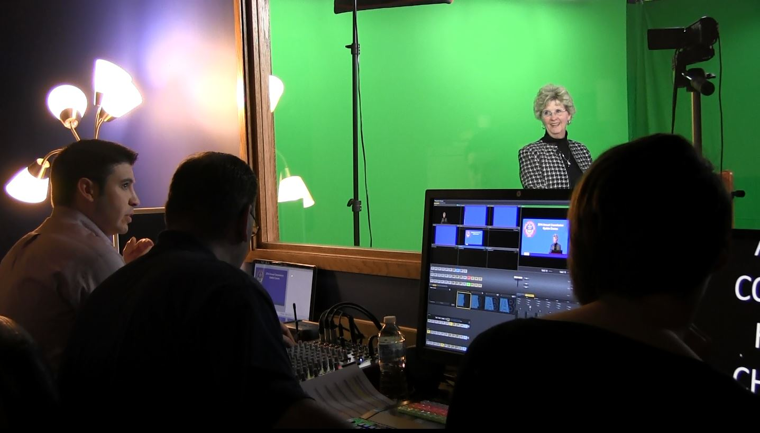
Webcast Set

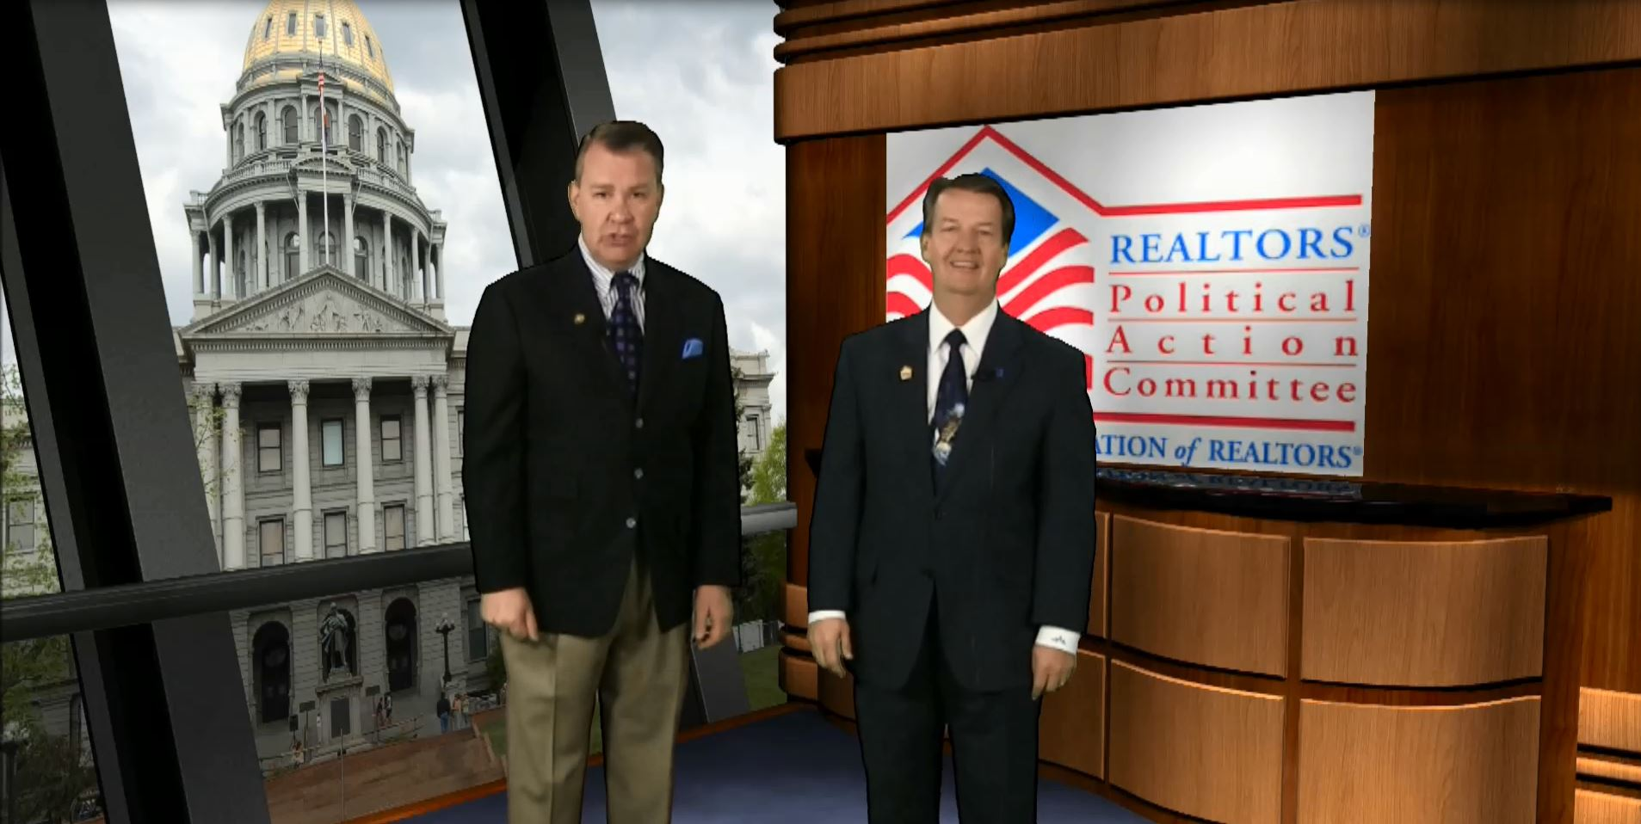
Webcast Set

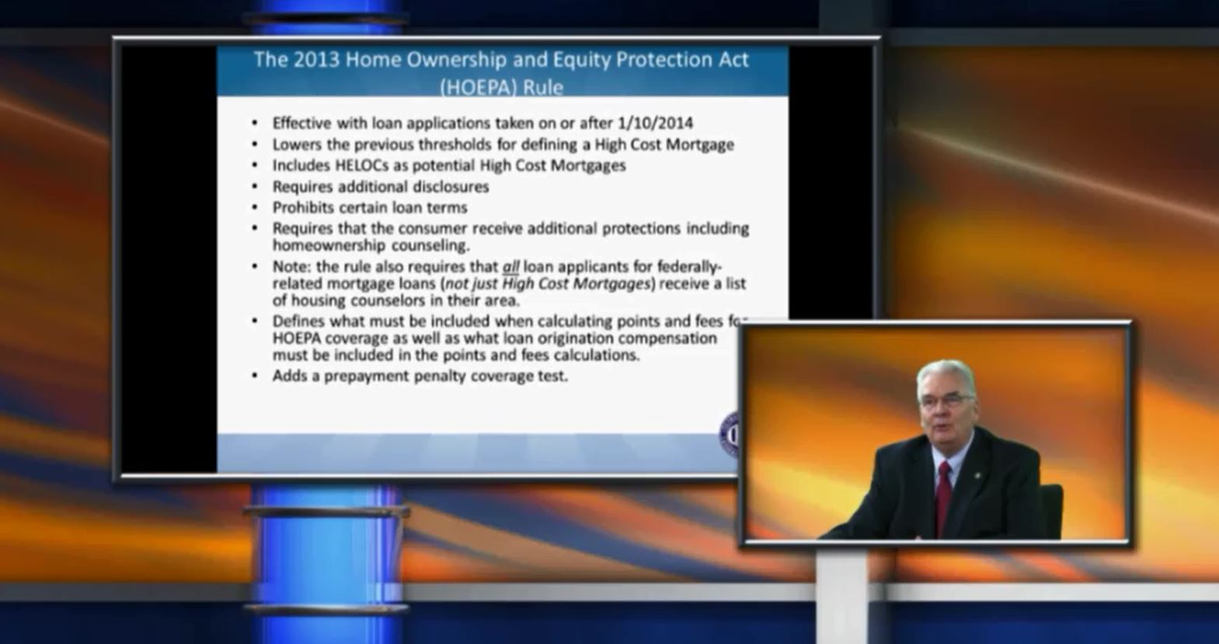
Webcast Set

