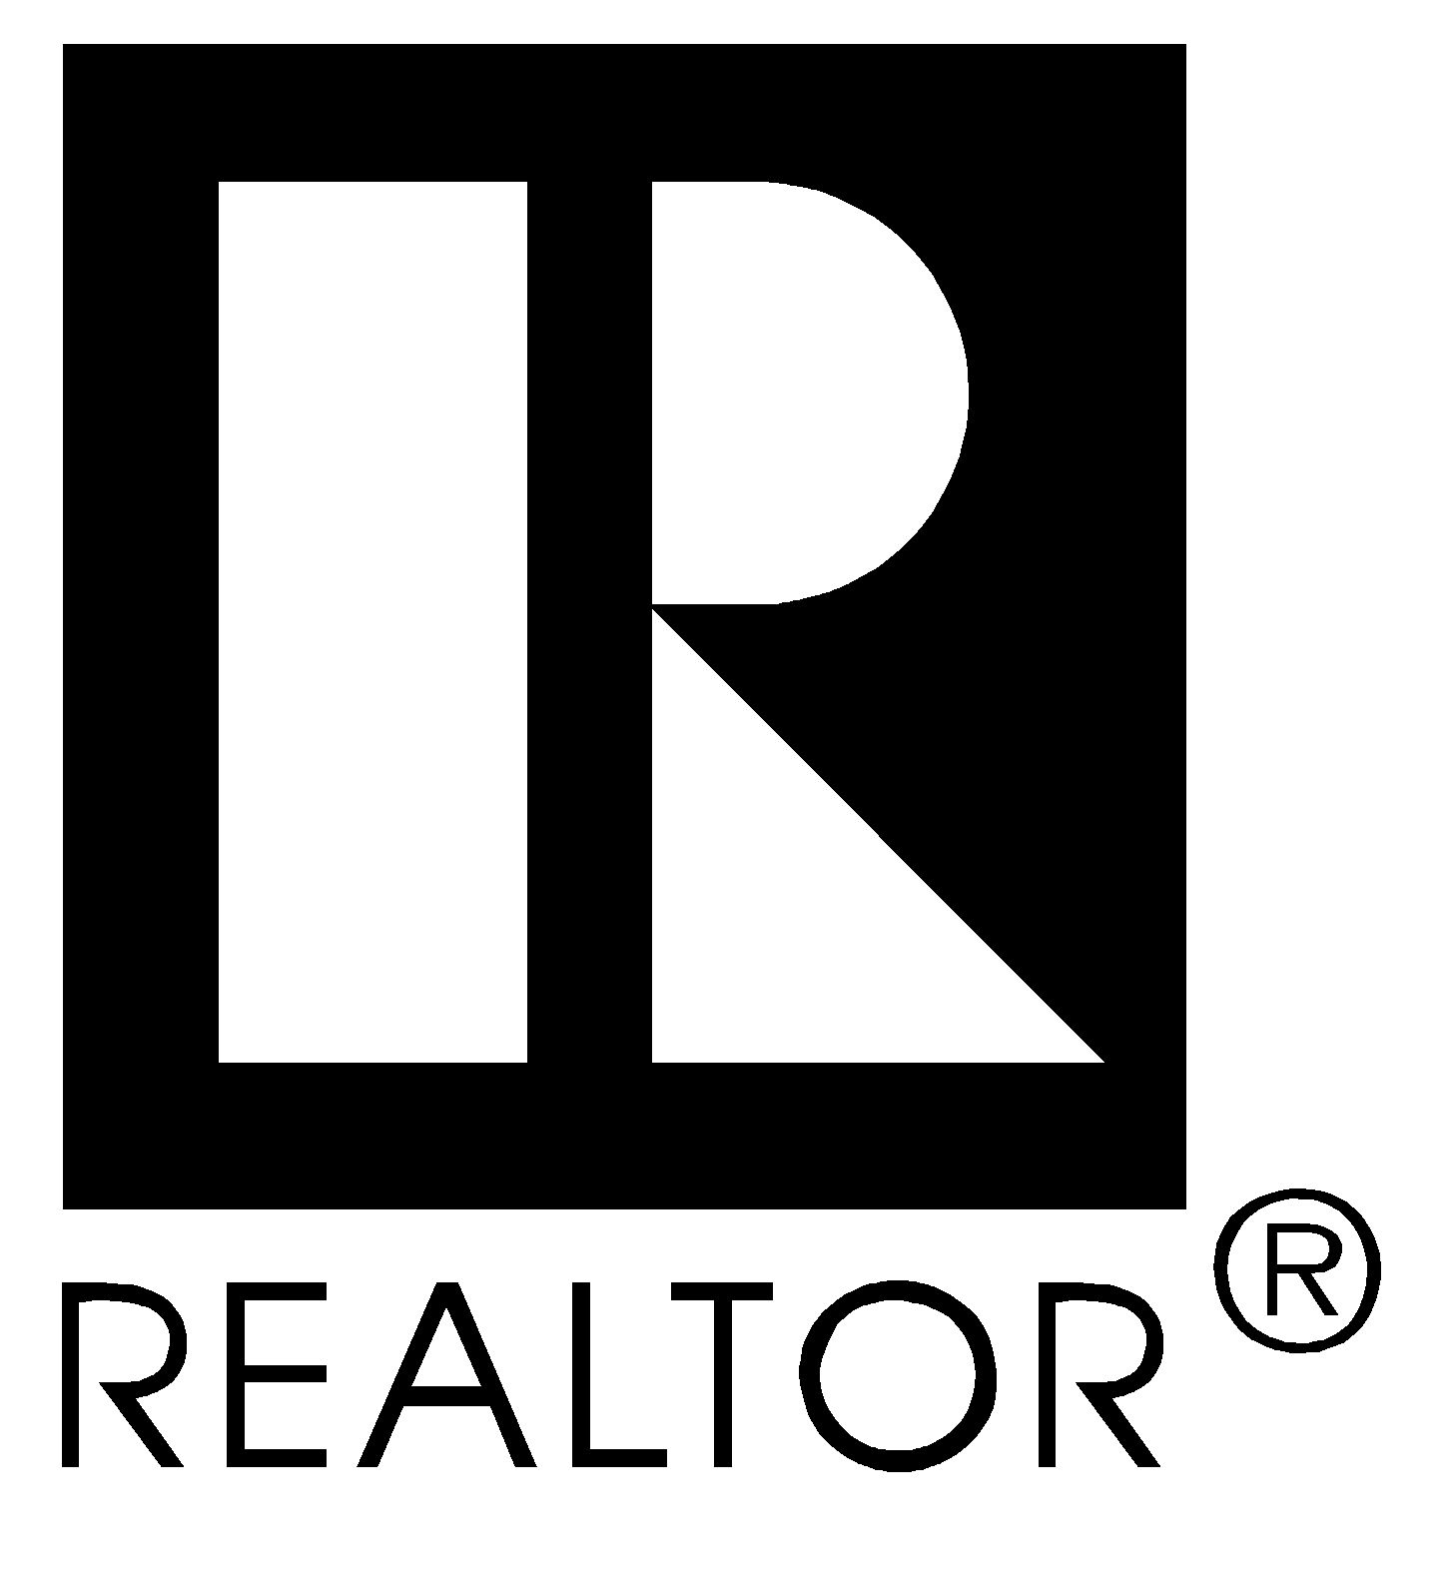

I am a REALTOR®

I Pledge Myself

To strive to be honorable and to abide by the Golden Rule;

To strive to serve well my community, and through it, my country;

To abide by the REALTORS'® Code of Ethics and to strive to conform my conduct to its aspirational ideals;

To act honestly in all real estate dealings;

To protect the individual right of real estate ownership and to widen the opportunity to enjoy it;

To seek better to represent my clients by building my knowledge and competence.

________________, 20__

_________________________ ________________________
Board President REALTOR®

I AM A

REALTOR-ASSOCIATE®

I Pledge Myself

To strive to be honorable and to abide by the Golden Rule;

To strive to serve well my community, and through it, my country;

To abide by the REALTORS'® Code of Ethics and to strive to
conform my conduct to its aspirational ideals;

To act honestly in all real estate dealings;

To protect the individual right of real estate ownership and to widen
the opportunity to enjoy it;

To seek better to represent my clients by building my knowledge
and competence.

_____________, 20__

________________________ _______________________
Board President REALTOR-ASSOCIATE®

