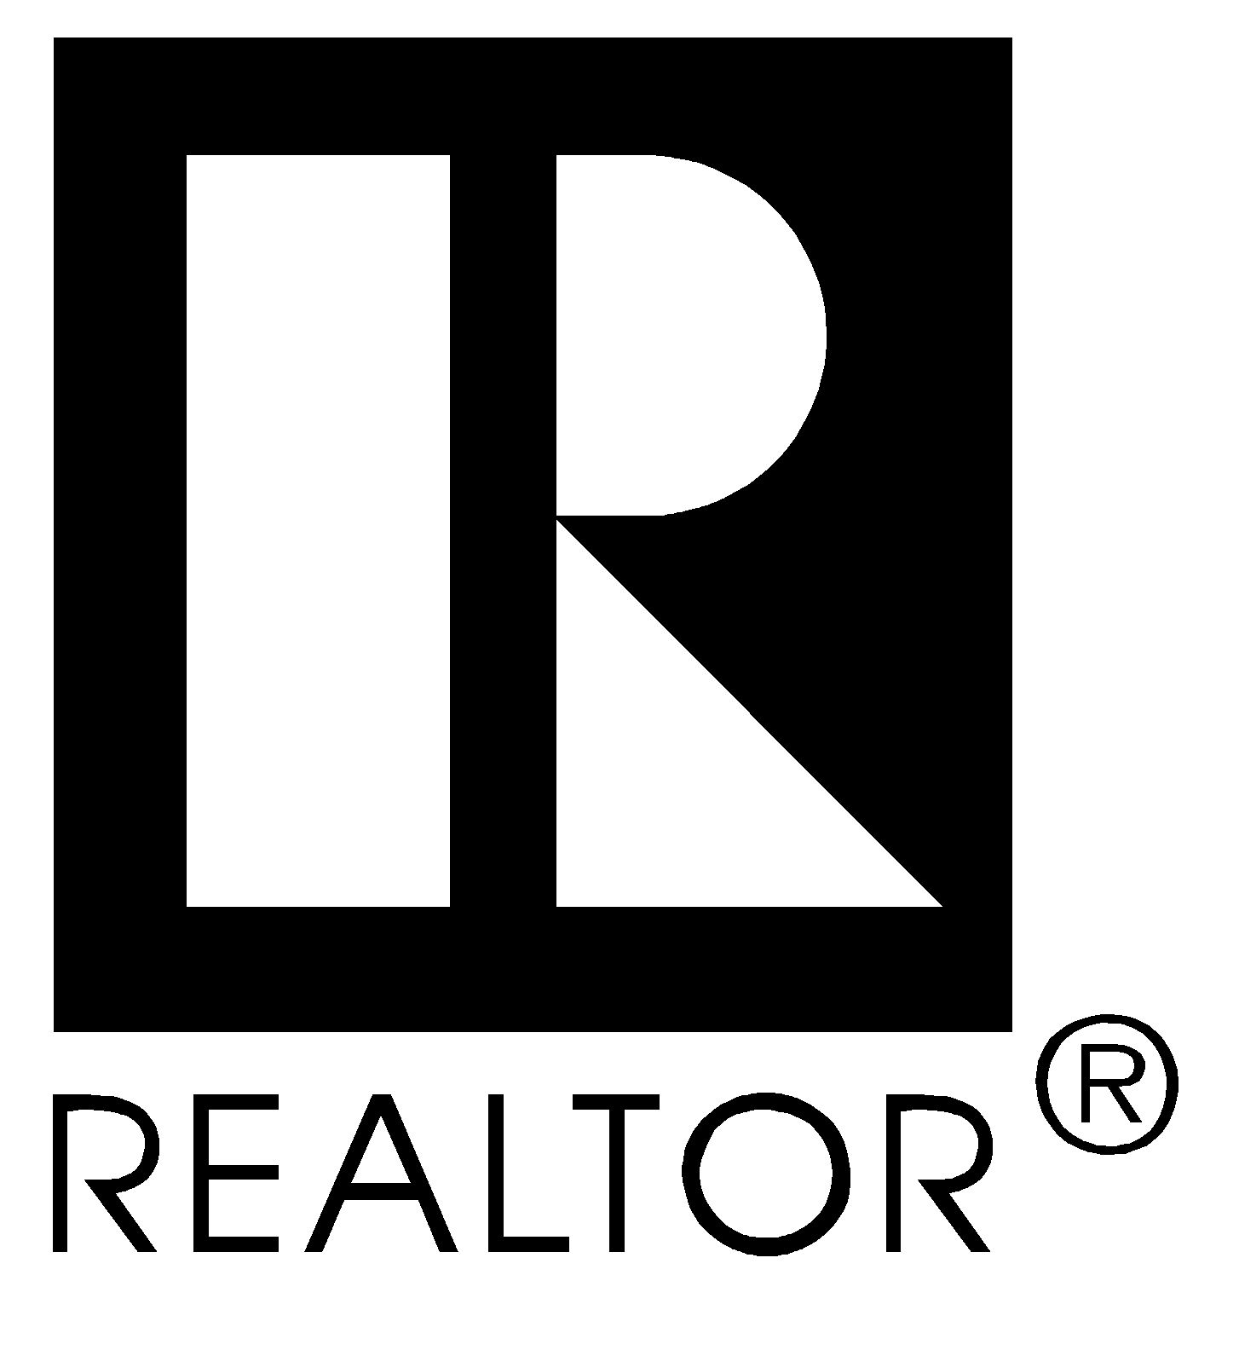

I am a REALTOR®

I Pledge Myself

To protect the individual right of real estate ownership and to widen the opportunity to enjoy it;

To be honorable and honest in all dealings;

To seek better to represent my clients by building my knowledge and competence;

To act fairly towards all in the spirit of the Golden Rule;

To serve well my community, and through it, my country;

To observe the REALTORS'® Code of Ethics and conform my conduct to its lofty ideals;

________________, 20__

_________________________ ________________________
Board President REALTOR®

