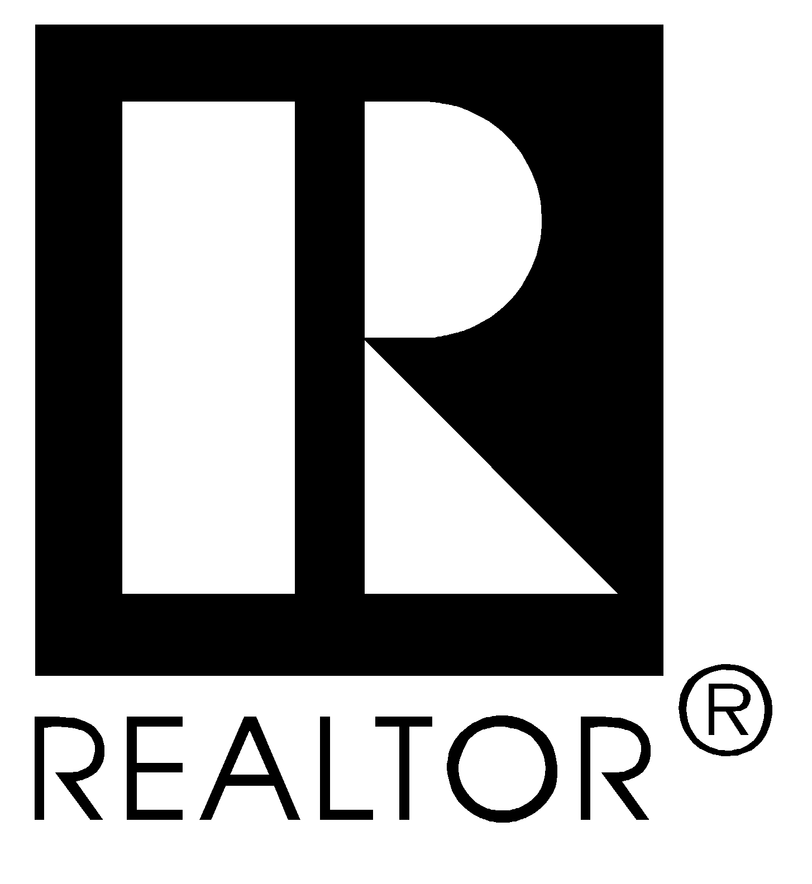
NATIONAL ASSOCIATION OF REALTORS®
430 North Michigan Avenue
Chicago, Illinois 60611

AGREEMENT TO USE THE TERM REALTORS®
IN THE CORPORATE NAME OF LOCAL BOARD

THIS AGREEMENT made this ____________ day of ________________, 20______, between the NATIONAL

ASSOCIATION OF REALTORS®, an Illinois Corporation, of Chicago, Illinois, hereinafter referred to as the National

Association, and the ___________________________________________________________________________, State of
(Name of the Member Board)

_______________________________________________________________, hereinafter referred to as the Board.

WITNESSETH:

WHEREAS, the National Association is the owner of all right, title and interest in and to the marks REALTOR®, REALTORS®, REALTOR-ASSOCIATE® and the "R and Design" mark, has the sole and exclusive right to license use of the marks REALTOR®, REALTORS®, REALTOR-ASSOCIATE® and the "R and Design" mark, said marks being registered under the Lanham Trade Mark Act of 1946; and

WHEREAS, the Bylaws of the National Association provide that the Board of Directors of the National Association, upon application from a Member Board, may license such Member Board to use the term REALTORS® as a part of its name upon certain terms and conditions; and

WHEREAS, the Board hereby applies to the Board of Directors of the National Association for license to use the term REALTORS® as a part of its name, and is willing to agree with the National Association that it will comply with all of the terms and conditions governing the use of the marks REALTOR®, REALTORS®, REALTOR-ASSOCIATE® and the "R and Design" mark set forth in the Constitution and Bylaws of the National Association and policies and rules from time to time promulgated by the National Association and protect the same within its jurisdictional territory;

NOW, THEREFORE, IN CONSIDERATION OF THE MUTUAL COVENANTS HEREIN CONTAINED, IT IS AGREED AS FOLLOWS:
1. The National Association agrees to and does hereby license the Board to use the term REALTORS® as a part of its corporate name, for so long as and only for so long as the Board remains a Member Board in good standing in the National Association, in the following style and form and in no other:

______________________________________________________________________________________________________________
(BOARD OF REALTORS® NAME - STYLE AND FORM)

2. The Board agrees that it will not use the term REALTORS® as a part of its name or in any other style or form than that above specified and further expressly agrees not to surrender, abandon or extinguish its corporate existence under the name hereby approved without written notification to and the prior written consent of the National Association and that all use by the Board and its Members of the foregoing name and marks REALTOR®, REALTORS®, REALTOR-ASSOCIATE®, and the "R and Design" mark shall inure exclusively to the benefit of the National Association.

3. The Board further agrees that it will protect the marks REALTOR®, REALTORS®, REALTOR-ASSOCIATE® and the "R and Design" mark within its jurisdictional territory. Where violations of the use or misuse of the marks occur by Members or nonmembers, within such jurisdictional territory, the Board will take steps to correct the violation or misuse and report such violations or misuses in writing to the National Association.

4. It is understood and agreed that the license hereby granted may be terminated and revoked by the National Association, after due notice and opportunity for hearing, upon determination by the Board of Directors of the National Association that the Board has failed to comply with this Agreement, or has failed to comply with or abide the provisions of the Constitution and Bylaws of the National Association or the policies and rules from time to time promulgated by the National Association, or has failed to observe or enforce the Code of Ethics of the National Association.

5. The Board expressly agrees that if it shall at any time, for any cause, cease to be a Member Board in good standing of the National Association, it will eliminate the term REALTORS®, from its name immediately, and will thenceforth refrain from using REALTOR®, REALTORS®, REALTOR-ASSOCIATE® and the "R and Design" marks in any form or manner in connection with its name or otherwise, until such time as again it shall have become a Member Board in good standing of the National Association and shall have been authorized by written agreement to use such term or marks in its name or otherwise. The Board further agrees that immediately upon ceasing, at any time, for any cause, to be a Member Board in good standing of the National Association, or upon revocation of the license hereby granted, it will take appropriate legal action to amend its name, Articles of Incorporation, certificates of doing business, Bylaws and other documents to eliminate the terms REALTOR®, REALTORS® and REALTOR-ASSOCIATE® and all uses of the "R and Design" mark and shall take all other reasonable action deemed by the National Association to be necessary or appropriate to assure that the public is not misled with respect to the membership status of the Board in the National Association.

6. It is agreed that the Board of Directors of the National Association shall have the sole and exclusive right to determine whether the Board is a Member Board in good standing of the National Association and whether the Board is in violation of this Agreement.

7. This Agreement shall be effective on the latter of (1) the date hereof and (2) the date on which the Board of Directors of the National Association grants its approval to the Board with respect to the terms of this Agreement and shall automatically terminate in the event the Board shall not perfect its corporate status within twelve (12) months of the effective date hereof.

IN WITNESS WHEREOF, each of the parties hereto has caused this Agreement to be signed by its President and its corporate seal to be affixed, attested by its Secretary, the day and year first above written.

Approved:  NATIONAL ASSOCIATION OF REALTORS®  By______________________________________________________  Signature of President  ________________________________________________________  Type or print name of President | Approved:  _____________________________________________________  Type or print name of Member Board  By_____________________________________________ ______  Signature of President  ________________________________________________________  Type or print name of President
Attest:  By______________________________________________________  Signature of Secretary  ________________________________________________________  Type or print name of Secretary | Attest:  By______________________________________________________  Signature of Secretary  ________________________________________________________  Type or print name of Secretary
(Seal) | (Seal)

For NAR use only

New Board approval date __________________________

Name change approval date ________________________

©NATIONAL ASSOCIATION OF REALTORS® 1996
Approved by Board of Directors November 16, 1977
All Rights Reserved
h:\bp&php\jurisdictional documents\agreement to use the term realtor – incorporated (revised 8/03)

